EXCEL ASSIGNMENT – DATA CLEANING AND TRANSFORMATION
Step 1: Data Cleaning
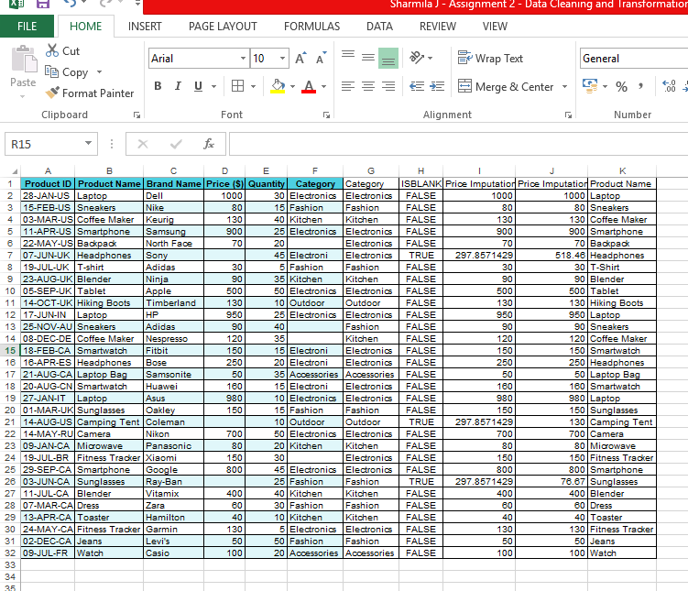

Explanation:
1. Removing duplicates:
Selected the complete dataset and used Remove Duplicates to identify and remove duplicate records.
2. Missing category values filling:
Identified the blank cells in the Category column and filled them based on the corresponding Product Name/type.
3. Correcting typo:
Used Find & Replace to correct the incorrect category name “Electroni” to “Electronics”.

4. Missing price values:
Identified the blank Price cells after correcting the category and used the AVERAGEIF formula to calculate the appropriate average Price based on the corrected category and filling the missing price value.

Step 2: Splitting and Merging Data:

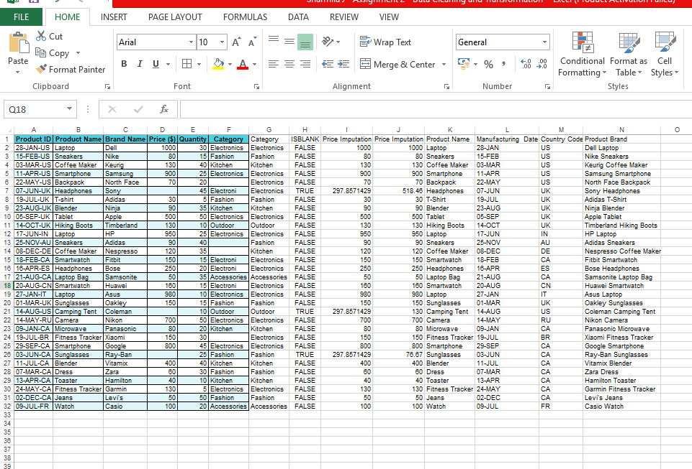

Explanation:
1. Product ID Splitting:
Used Text to Columns to split the Product ID into Manufacturing Date and Country Code.

2. Product Merging:
Merged Brand Name and Product Name into a new column named Product Brand using a concatenation formula.

Step 3 – Number Formatting: Explanation

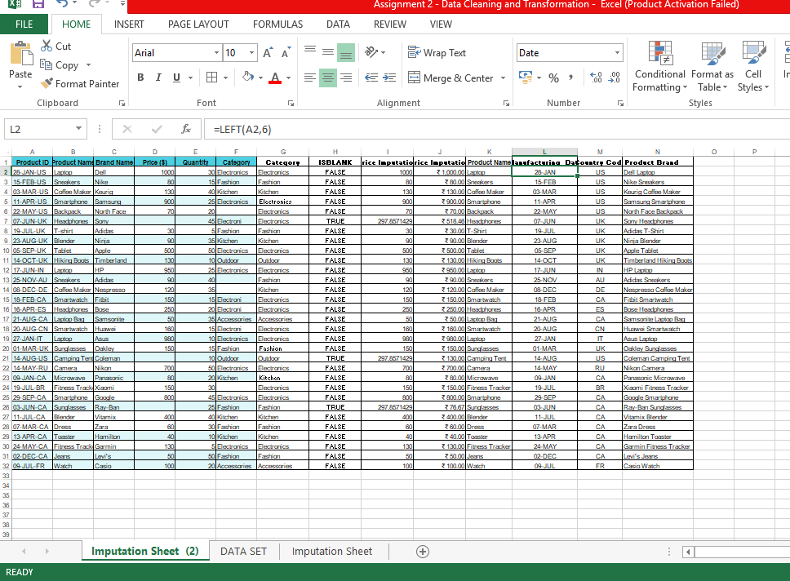
Explanation:
1.Price:
Formatted the Price column as Currency to display the price values consistently with the currency symbol and decimal places.
2. Manufacturing Date:
Formatted the Manufacturing Date as DD-MMM (for example, 28-JAN). No year was added because the original Product ID contains only the day, month, and country code.

Step 4 – Conditional Formatting:

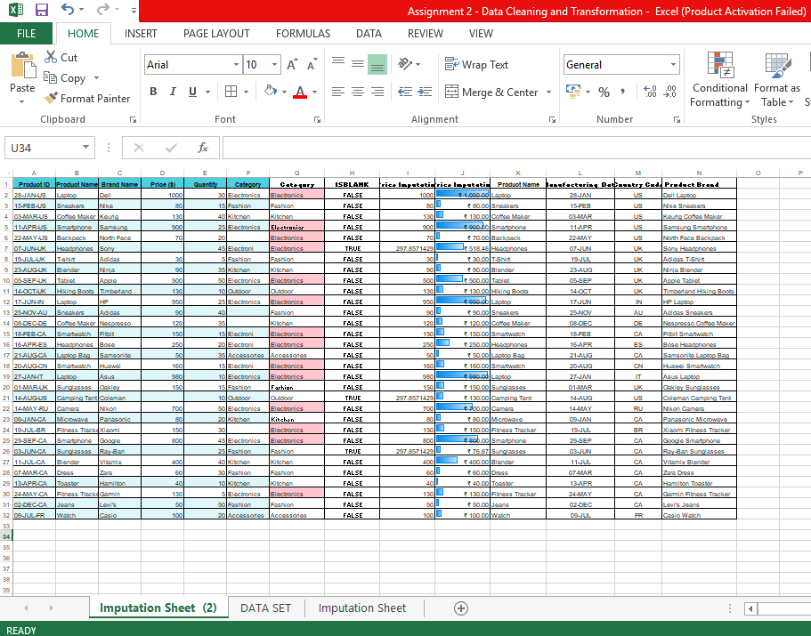
Explanation:
1. Price:
Applied Data Bars to the Price column to visually compare price values. Higher prices are represented by longer bars.
2. Electronics:
Applied Data Bars to the Price column to visually compare price values. Higher prices are represented by longer bars.

